## OAH Newsletter Digitization and Access Proposal

**Authors:**

Jason Evans Groth

Justin P. Peters

Nora Roggeveen-Sams

Robert Sheppard

**Client contact information:**

Organization of American Historians   
112 North Bryan Avenue   
Bloomington, Indiana 47408–4141

(812) 855–7311

**Primary Contact:**

Michael Regoli [mregoli@oah.org](mailto:mregoli@oah.org)

Table of Contents

Executive Summary 3

Problem Definition 4

Goals and Objectives 4

Reccomendations 5

Costs and Benefits 6

Description of the Current System 7

Narrative 7

Current workflow model 8

Cultural model 9

Reccomendations 10

Analysis Criteria 10

Narrative 10

Costs and Benefits 14

Reccomended sequence Model 15

Reccomended Workflow Model 16

Implementation 17

Implementation Narrative 17

Implementation Gantt Chart 18

Appendices 19

Organizational Chart Artifact Models 19

Interview Questionnairees 20

Survey Results 22

Cost and Benefits analysis spreadsheet 28

**Executive Summary**

**Current OAH Newsletter Storage and Retrieval System**

The *OAH Newsletter*, which began its print run in 1973 and was distributed to members of the Organization of American Historians, published its final issue in November of 2009. The decision to end the run of the *Newsletter* came in the wake of higher print costs and lower membership. Since 2009 the stock of physical copies of the *Newsletter* has dwindled, and the only known full set of the print run exists primarily in a closet in the office of Michael Regoli, Communications and Marketing Specialist at the OAH. While the Ruth Lilly archives at IUPUI is the official archive for OAH materials, their web presence indicates that, perhaps, a full run does not exist there (it lists the records of the OAH being current only through 2003).

Additionally, the digital archives of the *OAH Newsletter* which existed on the OAH website through 2009 are no longer available publically. If they were, only the issues published in May of 2003 and after are available as searchable PDFs. Prior to 2003 there are HTML versions of the *Newsletter* going back to November of 1995, but most are incomplete and hard to search. A full index of *OAH Newsletter* articles was compiled in 2009 by the former *Newsletter* editor, Ben Aloe, but all of the files were moved offline in 2010. The digital files that do exist are likely backed up, but on degrading CDs that exist without a finding aid and no specific preservation routine.

According to several staff members, if there is a need for an article or issue of the *Newsletter* they turn to Michael Regoli for help in retrieving it. Those who have worked at the OAH for several years know that he, as the former Director of Publications, will likely have an answer to discover the needed issue or article. They may even have access to the now-hidden directory, an artifact of the old server, which contains the only digitized copies of the *Newsletter*. Yet this is not common knowledge, and most staff, according to interviews, feel there is no need for the *Newsletter* in their day-to-day work lives.

Interviews with staff illustrated that some members and the general public occasionally make requests for issues or article of the *Newsletter*. If the request makes it to Michael Regoli, it has handled quickly and accurately. However, if a newer staff member or one who is unfamiliar with the *Newsletter* – and interviews showed that many staff people are unfamiliar – the request may not make it past the phone call or email. This is not due to the staff member being negligent, but rather is a reflection of the attitude that OAH employees have to the now out-of-print *Newsletter*: It is not a top priority, and thus no formal request models, storage scheme, preservation rules, or digitization plan is in place.

Interviews show that requests for content have decreased since the *Newsletter* ceased being printed in 2009. This makes sense, as those who may want to use the information will likely forget that it is even an option if it is not apparent that the information is available. As there is no presence on the OAH website, and the IUPUI Archives website does not list it obviously, a member may be disinclined to contact an OAH representative, especially if they would rather browse the information themselves. There are currently no plans to make the currently digitized *Newsletter* accessible to staff, members, or the public, let alone a digitization plan for the remainder of the collection.

**Problem Definition: Setting**

The Organization of American Historians (OAH) is the world’s largest learned society devoted to the study and dissemination of American history. Founded in 1907, it is a non-profit organization with an individual membership of over 7,000 and an institutional membership of over 3,000. In 1973 the OAH Executive Board voted to begin the *OAH Newsletter*, a publication meant to inform the membership body about news of the organization itself, its members, and the profession, as well as the actions of the Executive Board. The *OAH Newsletter* was printed and distributed until 2009, when costs to the organization outweighed the benefits of publication. While the other publications of the OAH – The *Journal of American History* and the *OAH Magazine of History* – continue life on the web via digitization, years of the *OAH Newsletter* before desktop publishing exist solely in bound volumes in the OAH office, and even the digital issues are available in perpetuity only to OAH staff.

**Problem**

There is no system in place to successfully digitize the backlog of non-digital copies of the *OAH Newsletter*, nor is there infrastructure to host the currently digital copies online. While the *Journal of American History* in digital form is handled by JSTOR and other cooperative agreements and the *OAH Magazine of History* is meant for a wider audience and also as a tool to attract teachers to the organization, the *OAH Newsletter* has less immediate value in digital form -- not only for marketing efforts but also for internal use, as paper copies exist in the OAH office. Without a system to preserve the *OAH Newsletter* there is a threat that the remaining copies and digital files will not survive.

**Scope**

The problem has many potentially severe consequences. First, an organization devoted to history should be interested in preserving its own. The *OAH Newsletter* exists as a log of institutional history, and a meta-history for the profession itself. If the paper-only copies are not preserved, they are subject to being lost indefinitely. If backups of the digital files are not made they, too, will suffer the same fate. At the moment there is not great demand for back issues of the *OAH Newsletter*, largely due to the fact that much of the material is not indexed in many smaller libraries or in databases. When there is demand, and it is for older, non-digitized material, a staff member must scan or copy individual articles and email or mail them to the members in need. There is arguably enough important professional history that, if made available, would serve researchers well, and would also eliminate the need for staff to break their workflow and make one-off copies of material that is worthy of preservation and being accessible to the world via the web. As of now, none of the material is available online.

**Goals/Objectives**

The problem will be solved successfully when every issue of the *OAH Newsletter* is digitized, preserved, and indexed in such a way that, when time, money, or demand allows, OAH staff can effectively open access to the contents of the publication to the public. A digitization plan, proper equipment and facilities, hours to perform the digitization and indexing, and the willingness of staff to cooperate on a long-term preservation goal are all criteria for a successful elimination of the current problem.

**Recommendations**

It is recommended that the Organization of American Historians select one of the two following options to successfully digitize, make accessible, and help insure the long-term preservation of the *OAH Newsletter*:

**Option 1:** Partner with the Indiana University Digital Library Program, the Indiana University School of Library and Information Science (SLIS), and IU ScholarWorks to digitize the entire run of the *Newsletter* and then place it in the IU ScholarWorks public, online, scholarly repository.

**Option 2:** Partner with the IUPUI archives to digitize the entire run of the *Newsletter* and then place it in their online, public repository

In **option 1**, the OAH would work directly with Michelle Dalmau of the Indiana University Digital Library Program (DLP). Michelle has expressed interest in helping move the project along by offering to set up an internship through SLIS and then manage it in the DLP. The student chosen would earn school credit as well as a project management credit for their resume. The student would scan the entire run of the *Newsletter* using paper copies supplied by the OAH office. Both preservation copies (likely 600-1200 DPI) and access copies (300-600 DPI) would be created and stored in perpetuity by the DLP, and scanning would be complete within one semester. Metadata guidance and supervision would be given by Jennifer Laherty of IU ScholarWorks. Once the run is digitized and metadata is entered, the student would upload the run to IU ScholarWorks, where the *OAH Newsletter* would sit amidst other, diverse scholarly publications from Indiana University. The *Newsletter* would be available to staff and members of the OAH as well as the general public.

In **option 2**, the OAH would work directly with Brenda Burk of the IUPUI Archives and the OAH archivist. The physical archives of the OAH already exist at this location, and Brenda is in charge of them. Brenda would also set up an internship through SLIS in Indianapolis and manage it at IUPUI. The student will earn school credit and be able to add the experience to their resume. The student would scan the entire run of the *Newsletter* using paper copies supplied by the OAH archive. Access copies (300 DPI) would be created and long-term preservation would be guaranteed by the Ruth Lilly Archives. Scanning will likely take one semester. Brenda would be in charge of metadata supervision and, once the scans are created and the metadata entered, the files would be placed in eReserves at the IUPUI archives, available to staff and members of the OAH as well as the general public.

**Costs and Benefits**

With both options the OAH spends both very little money and time to achieve the stated goals of both preserving and making accessible the *OAH Newsletter*. The up-front costs are mostly that of the staff time of Michael Regoli, who would be the contact for this project. An initial meeting with the DLP/ScholarWorks/IUPUI archives would lead to an intern being selected, and from that point either the DLP or IUPUI would be in charge of keeping the project in order. The staff time and money required by the OAH extremely low, and is negligible compared to the benefits produced by the options: Access to the *OAH Newsletter* Is provided for staff, members, and the general public; preservation in both the physical and digital realm is guaranteed; the job will be completed quickly; the job will be of high quality; the project offers the OAH the chance to collaborate with scholarly entities (DLP and IUPUI archives) interested in the content the OAH has to provide.

DESCRIPTION OF CURRENT SYSTEM.

Although the *OAH Newsletter* is no longer in print, back issues contain information about the organization and the field of American history that OAH members, OAH staff, and the general public may want to access. Currently a request for an issue of or article from a past edition of the *OAH Newsletter* will come in the form of an email to one of the OAH staff members or a phone call to the OAH office. Depending upon how the request is received, the requestor may get a different outcome due to the various breakdowns illustrated in the current workflow model (figure X of the appendix). Most of the time a request for an article or issue is routed through Michael Regoli. However, from interviews with OAH staff, it is apparent that not all staff members know how to address a request for an article or issue.

There are other staff members in addition to Michael who can, currently, fulfill requests for Newsletter issues or articles as they are received, but it is not part of their job duties and takes away from other primary job functions.

When a staff member who knows how to handle a request receives one, it can be fairly time consuming to locate the physical copy of the requested issue. A set of the complete run (mostly bound) is stored Michael Regoli’s office closet at the 112 N. Bryan Ave. Other paper copies – mostly of later issues – are unbound, and exist in various locations at both 112 N. Bryan and 111 N. Bryan. An archived set of paper copies, which is believed to be incomplete, exists at the IUPUI archives. The IUPUI archive has digitized some of the *Newsletter*s it possesses but the records stop at 2003 and have incomplete metadata which is unsearchable. The *Newsletter* was produced in a digital format, along with the paper format, from 2003 to 20009. A collection of these PDF versions of the *Newsletter* exist on an OAH server but the existence of these files is only known by a few staff members. In order to fulfill requests for older issues, a scan or photocopy may require unbinding the book in which it is stored. Low quality scans and copies are possible within the binding, and if extra copies of later issues of the *Newsletter* still exist they can be shipped to requestors.

The current system, as described above, only refers to the issue of access to the newsletter. While providing access is the primary focus of this project, a secondary concern is that of properly preserving the content of the *Newsletter*, for both institutional reasons and as a record of the actions of those involved with the field of American history from 1973-2009. Additionally, OAH staff members have indicated through interviews their eagerness to free up office and storage space by making the newsletter available in a digital archive and moving all physical copies to the IUPUI archives.

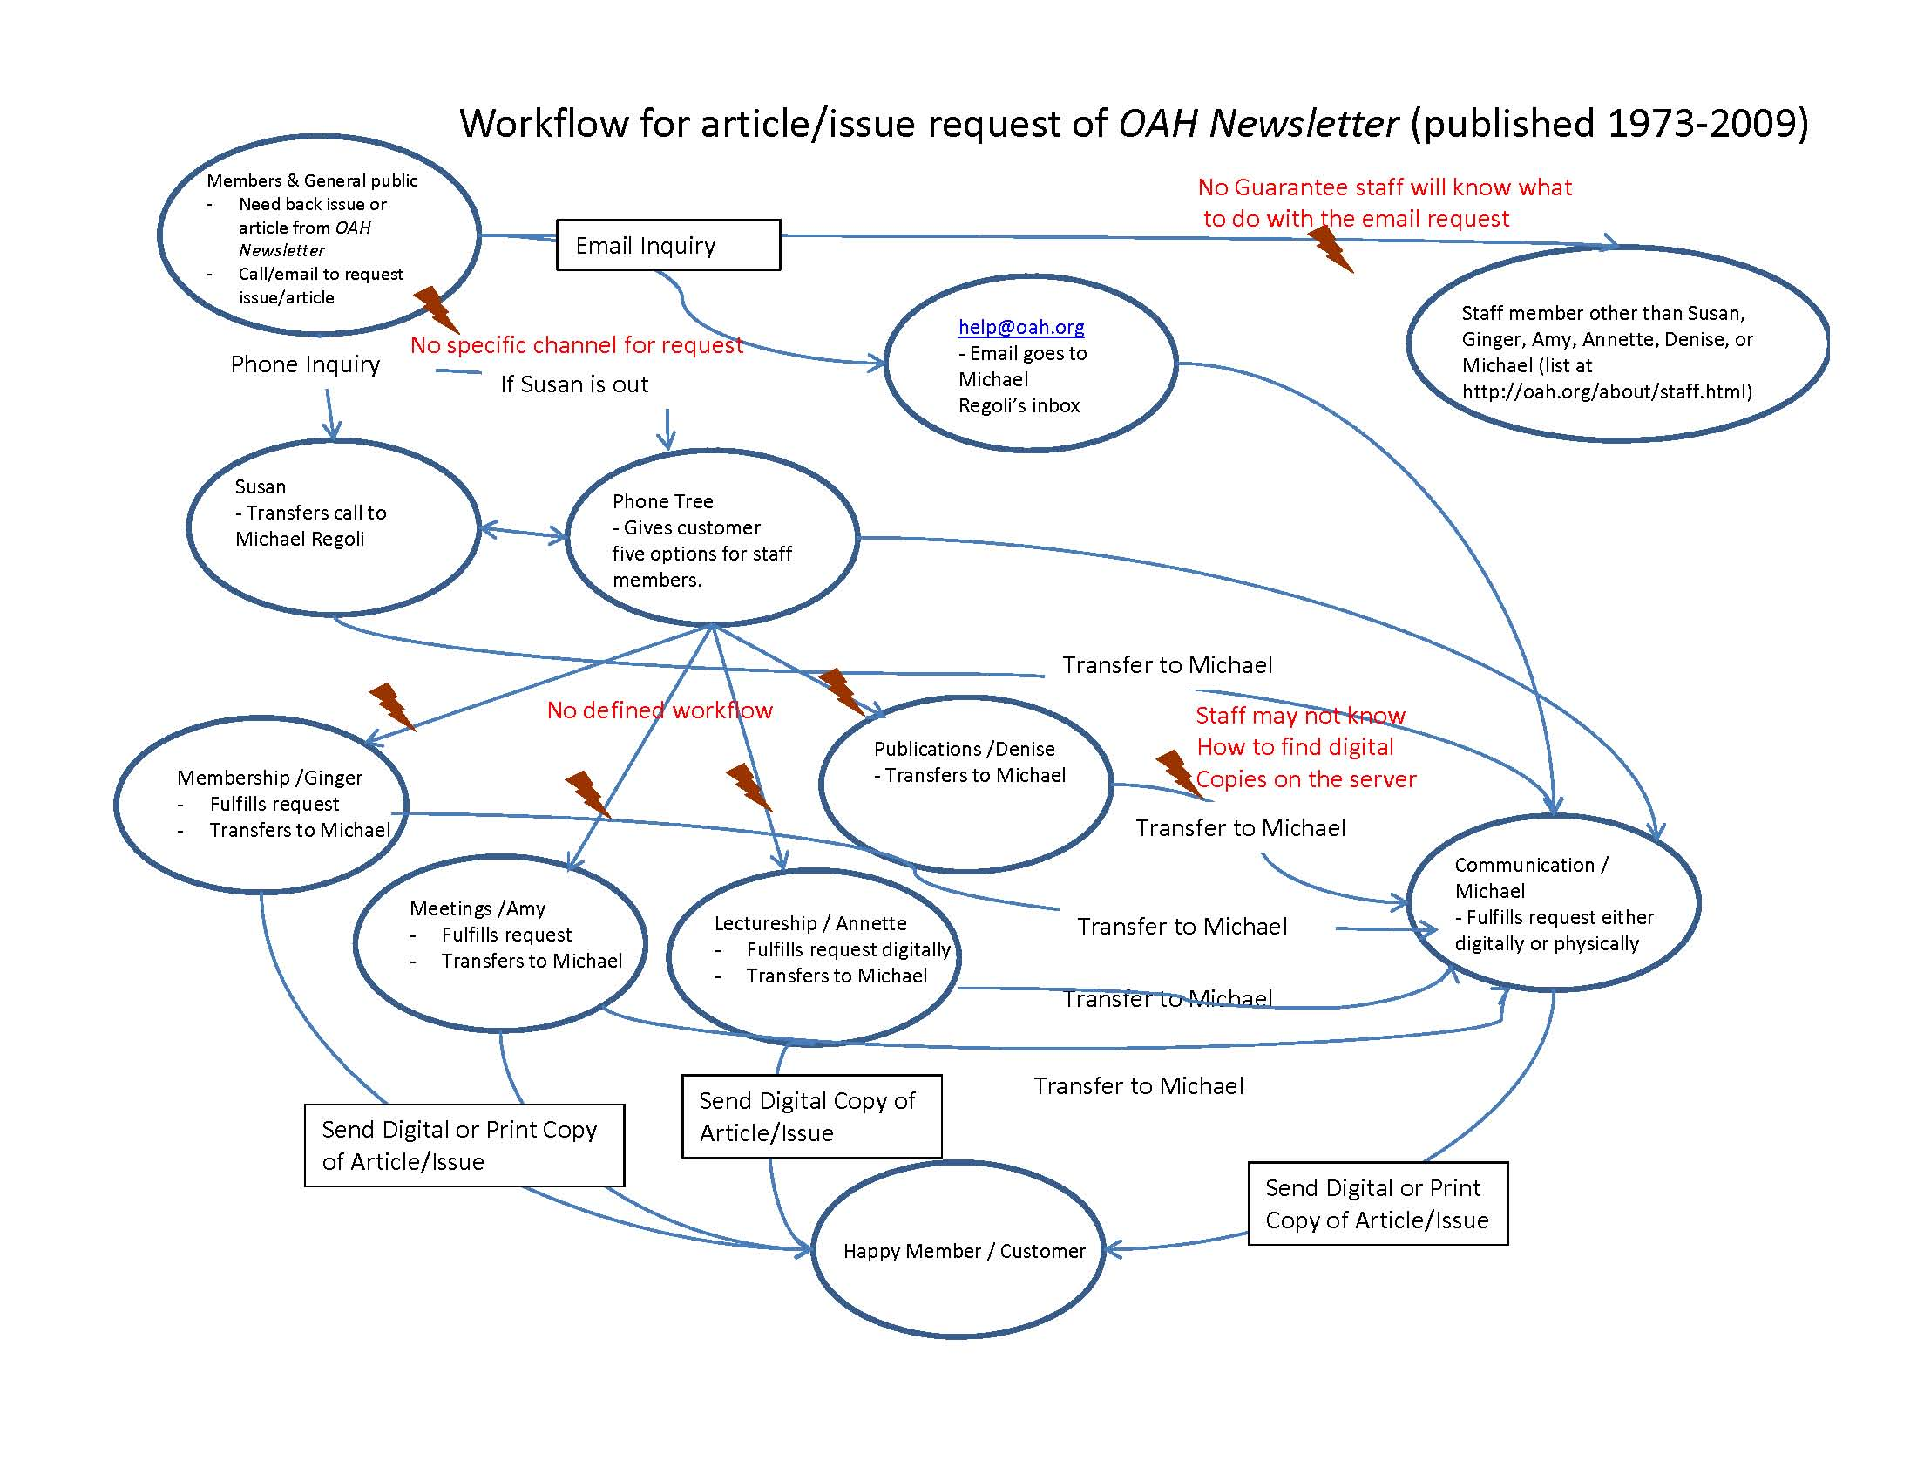

Figure 1. The current workflow has many breakdowns including the lack of a specific channel for requests, no defined workflow, and staff that may not be able to handle requests.

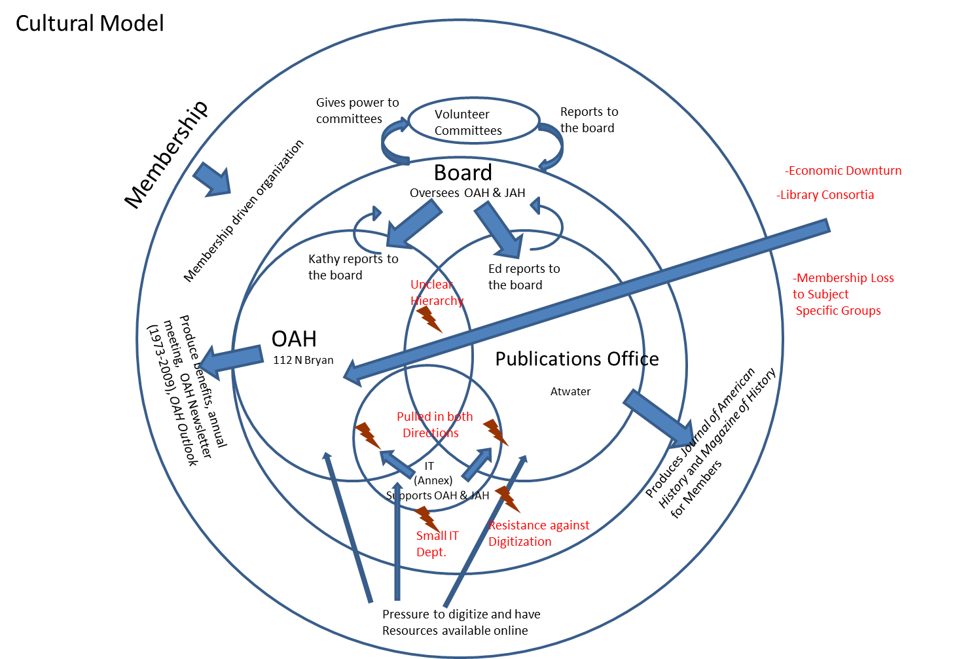

Figure 2. The model above is that of a cultural model of the OAH. Breakdowns include a small IT department that is pulled in multiple directions to provide support, an unclear hierarchy, and resistance of some within the organization to provide digital access.

RECOMMENDATIONS FOR NEW SYSTEM.

Our group conducted nine interviews (see Appendix X) with various individuals involved in the OAH, in digitization and archiving, and the editor of the Journal of American History. Through these interviews it was determined that the *Newsletter* could possibly add value to the organization. Several suggested that they could not see a reason not to offer digital access to the members but could not foresee investing time and resources into doing the job. The interviews led the authors to believe that the OAH is a small organization that does not have extra funding for special projects nor does it have the technology department to do the work. However, the Marketing and Communication Specialist, Michael Regoli, was able to send out a survey to the OAH membership to find out the level of interest of the *Newletter* being digitized and made available. The group, with contribution from Mr. Regoli, created the survey (see Appendix X). Though the response was low, only 35 members of 7,000, 89% said that they would be interested in having the back issues of the quarterly *OAH* *Newsletter* as an online resource. Similarly, 86% said it would benefit members of the OAH if back issues of the quarterly *OAH Newsletter* were available online. Thus, we determined analysis criteria for weighing the digitization options.

**Analysis Criteria for Deciding a New *OAH Newsletter* Digitization System**  
**1)** Cost (most important)  
**2)** Access   
**3)** Preservation

**4)** Speed  
**5)** Quality   
**6)** Creating Collaborative Opportunities with IU (least important)

The OAH position as a nonprofit organization limits some of the more grandiose solutions that could be put forward to the organization. Cost was outlined by the OAH as a major concern for any solution. The *OAH Newsletter* problem is an issue for the organization but through the interviews it was determined that it is not one they feel requires a heavy allotment of resources.

It was also found, through the survey of OAH members, that 74% of members consulted past editions of the quarterly *Newsletter.*

The OAH did have some concerns regarding the speed by which any solution could be completed. As a group we felt that the OAH would be best served by completing any solution to the *Newsletter* issue within the next year, as our investigation had created some interest in a topic that had been largely ignored since the publication went out of print in 2009. Interviews seems to have peaked an interest from those involved and, as a survey has been conducted, it would be in the interest of the OAH to produce the product sooner rather than later.

Our main contact with the OAH, Michael Regoli, was concerned with the quality of what would be produced by any of the digitization options. Michael wanted any digitized material to be of equal quality to that of other journal publications.

The final goal of a new system was altruistic in a nature. From talking with the OAH staff it was clear that they were interested in creating stronger collaborative bonds with Indiana University. Both the OAH business office and the publication office hope to establish more opportunities for internships for graduate students, especially within the School of Library and Information Science. The OAH felt that this would be a good source of labor for their varied projects and would help them contribute to the academic goals of the university.

**Recommendations to Make the *OAH Newsletter* Accessible to Staff, Members, and the General Public**

In order to increase access and usage of the *OAH Newsletter*, we recommend digitizing the complete print run (1973-2009) and making it available online. There are several considerable obstacles which have, heretofore, prevented this project from starting: Staff time is limited; there is no money in the budget for new hires to accomplish this goal; the *Newsletter*, while recognized internally as a valuable source of not only institutional history for the OAH but also a record of activity for the field of American history itself, is not as pressing an issue as others which have presented themselves to the OAH both while the *Newsletter* was in print and since it has gone out of print; in general, money, resources, and technology have been too limited to make the project a reality for the organization. We have identified two distinct options that address all of these obstacles and make digitization of and, subsequently, access to the *OAH Newsletter* a reality.

The first option provides for the digitization of the *Newsletter* under the direction of the Indiana University Digital Library Program (DLP). Michelle Dalmau, an employee of the DLP who has expertise in e-text projects, has agreed to create an internship within the DLP through the School of Library and Information Science (SLIS) at Indiana University, Bloomington. There are many positive benefits to this scenario: It requires very little staff time at the OAH to initiate the project; the DLP already has the infrastructure to support not only the technical aspects of such a project, but also the space to accommodate an intern; Ms. Dalmau already has expertise in such projects, so training time will be reduced; and, because the internship is offered through SLIS, prospective students will be motivated to participate for the experience of managing such a project, in addition to the credits provided by internships.

The student intern will scan the entire run of the *OAH Newsletter*. Judging by similar projects, the scanning will likely take between six and eight weeks. Jennifer Laherty of IU ScholarWorks has offered space within the ScholarWorks database for the run of the *OAH Newsletter*. She will offer metadata guidance with which the student performing the scanning will follow so that, once scanning is complete, the *Newsletter*, now fully searchable, can be uploaded to ScholarWorks and be appropriately searchable. IU ScholarWorks will place the *Newsletter* amongst many other scholarly publications that have been produced at Indiana University, as well as making the *Newsletter* available to anyone who wishes to find it online. Additionally, the scanning will produce both digital preservation copies (in TIFF format, scanned at least 600 dots per inch, and perhaps higher, depending on the advice of Ms. Dalmau) and access copies. The fully searchable access copies will not only be uploaded to IU ScholarWorks but also given to the OAH and to the IUPUI archives (who currently hold the paper records of the OAH, including the entire run of the *OAH Newsletter*). Should the OAH and IUPUI choose, these copies can be included on their websites if they so choose.

In summary, these steps must be followed if this option is chosen:

1. The OAH meets with the DLP, IU ScholarWorks, and the IUPUI archives to officially agree to the plan.
2. Michelle Dalmau works with Howard Rosenbaum of SLIS to establish the internship position (possibly beginning summer 2012, but likely starting the fall semester of 2012).
3. The OAH supplies Ms. Dalmau with the unbound copies of the *OAH Newsletter*;
4. An intern is “hired” for the project and given the project materials and training in the DLP.
5. The intern works with Jennifer Laherty to determine the appropriate metadata for inclusion in IU ScholarWorkss.
6. The intern scans the run of the *Newsletter* and keeps track of the chosen metadata.
7. The student uploads the access copies of the digitized *Newsletter* to IU ScholarWorks and the preservation copies are stored in the DLP infrastructure.
8. Access copies are given to the OAH and IUPUI.
9. OAH and IUPUI link to ScholarWorks to provide access to the *OAH Newsletter*.

The second option also involves an internship as well outsourced management, therefore reducing the OAH’s monetary and time costs. This option relies upon Brenda Burk, IUPUI archivist and archivist of the OAH, creating an internship at the IUPUI archives to digitize the entire run of the *OAH Newsletter* and make those digital copies available on the IUPUI archives website. Ms. Burk has agreed to this, and has forecasted that the scanning and metadata entry should take between six and eight weeks. The internship would be through SLIS in Indianapolis, thus offering the same benefits for the student intern as the first option. The digitized files would be available on the OAH eCollection page at <https://archives.iupui.edu/handle/2450/484>. Additionally, long-term digital preservation is guaranteed by the Ruth Lilly Archives. The OAH will be given access copies of the digitized *Newsletter*, and the archive page will be updated to reflect the new digital components of the collection.

If this option is chosen, these steps must be followed:

1. The OAH meets with Brenda Burk to begin the project.
2. Ms. Burk sets up the internship through SLIS in Indianapolis.
3. Ms. Burk finds and trains the intern.
4. the intern scans and supplies appropriate metadata to the individual issues of the *OAH Newsletter*.
5. Ms. Burk makes the scanned copies available through the IUPUI archives web page.
6. The OAH is given scanned access copies.

Both options accomplish the goal of digitizing and making accessible the run of the *OAH Newsletter*. The first option, we feel, is more robust; it creates more digital copies, puts the copies in multiple repositories, and increases findability while, at the same time, allowing the OAH to make connections with more Indiana University organizations like the DLP and ScholarWorks. Option two, while not as robust, accomplishes similar goals but with a few concerns: There is a question as to whether the entire run of the *Newsletter* is at the archives: the current website says the collection only runs through 2003. Also the OAH has not been able to supply financial support to the archives for some time. However, the second option may prove to be more politically correct. In either case, the *Newsletter*, currently inaccessible to staff, members, and the public, in both cases becomes a usable scholarly resource for staff, OAH members, and the general public.

**Cost and Benefits**

The two options we are proposing meet all of our requirements and in the end have largely similar strengths and weaknesses. They also take into consideration all that was learned through the interviews and the survey. Both of the options are cheap, deliverable in a semester, produce an accessible and searchable digitized project, preserve the physical copies, allow online access, and create an internship opportunity for a graduate student looking for project management experience. The reasoning behind proposing the two options has a lot to do with the politics surrounding the OAH and how its archival materials are handled. The largest cost to the OAH is that of political capital. The two options we are proposing require the organization to make a choice between using services offered by Brenda Burk, IUPUI archivist and archivist of the OAH, with whom the OAH has trusted their archives since the 1990s but who also has not been proactive in digitization initiatives and who has not updated their online archival presence since 2003, and the IU Digital Library Program, which offers quick, high-quality work which creates accessibility to a large portion of the academic population through IU ScholarWorks. This choice is a difficult one, as the OAH would like to preserve a good relationship with IUPUI, but also believes that the DLP option provides more benefits, potentially at the cost of alienating their archivist. From our feedback meeting with Michael Regoli and Kathy Finley it was made clear that the goal of any solution “was to get the project completed with the most benefits.” With this in mind it is apparent that if the OAH is willing to expend some political capitol then the first option of creating an internship through the Indiana University Digital Library Program is the best option. If the OAH feels that the political cost of distancing the project from Brenda Burk is too high then the second option of creating an internship through IUPUI is how the organization should advance the project.

It should be noted that, since our investigation into this problem began, the OAH has discovered that it has not been providing enough financial support for the IUPUI archives. They are happy with the services the archives provide for their physical materials and are proposing a yearly $2,000 gift to support the work of the archives. They have no ill for the archives; our interview with them indicates that they simply want the best option for the digitization of the *OAH Newsletter*, and they feel that the Digital Library Program offers a solution that is beneficial for their office, members, the general public, and creates less work for Brenda and her staff while delivering a digitized product which can be added to the archives. Yet the final decision needs to be made carefully by OAH staff, ideally after examining and discussing their relationship with the IUPUI archives.

Whichever way the OAH decides to go the new system will come at little to no financial, staffing, and resource cost. The new system will meet the needs of preserving the institutional history of the OAH while providing digital access. This digital access is another member benefit the OAH can highlight to current and prospective members. The open access nature of the digitization of the *Newsletter* could lead to new members being generated as it creates a free way to see more about the OAH.

See cost benefit analysis diagram appendix figure 9.

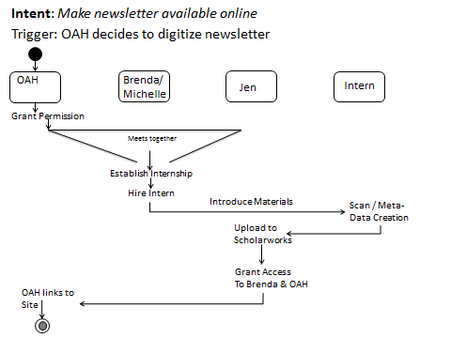

Figure 3. A revised sequence model to illustrate the steps involved in implementation of the project reccomendations.

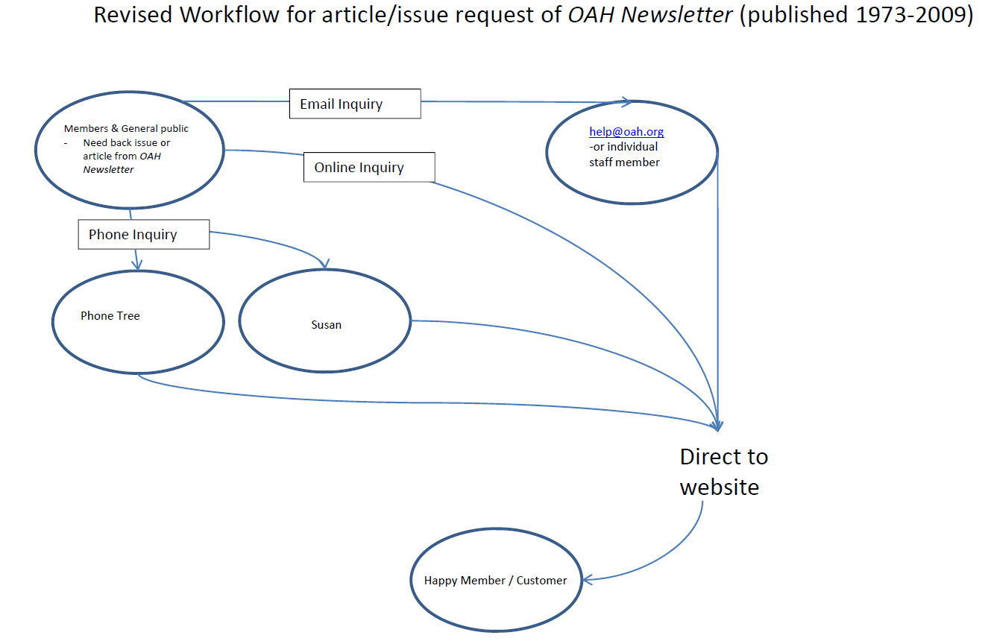

Figure 4. Above is a revised workflow to illustrate how requests will be handled after implementation of the new system. All forms of requests will routed to an online index of digitized issues of the OAH newsletter.

IMPLEMENTATION SCHEDULE FOR NEW SYSTEM.

**Feedback from Clients**

Both Michael and Kathy were pleased with the suggestions, especially those that indicated university-related entities were interested in helping preserve the *OAH Newsletter* archives digitally as well as provide derivative access copies. Kathy quickly pointed out that she wished to see an option that “didn’t cost any extra money,” so the options that did not involve hiring or purchasing equipment seemed to be the only left. Michael ruled out “doing nothing” and examined our new flow model for *Newsletter* requests. He was intrigued mostly by the DLP options, especially because it created new collaborative efforts between Bloomington-based, University-backed, educational initiatives. We had thought he would be most excited about the IUPUI archives but, as we found out, his relationship with the archivist and the archives has been strained in the past. The OAH gave a $10,000 gift to the archives when they took them on in the late 1990s, but has not provided money since. He is not convinced that they hold the entire run of the *Newsletter*, especially because the website only indicates them having a complete collection through 2003. And, despite the archivist assuring us that she had interested students, Michael is not convinced that this would happen quickly, if at all. We expressed our concern about duplication of efforts and the IUPUI archivist’s concern that she would be surprised if others (specifically the DLP/ScholarWorks/AIM) took on digitization. Michael was not concerned about burning this proverbial bridge – his concern, he said, was to get the project completed with the most benefits, and the DLP seemed to offer those whereas the IUPUI option is further away, has a history of not being a great relationship, and is not as thorough as our interview with the archivist had led us to believe. The outcome was that he wished us to explore the DLP internship option and speak with Jennifer Laherty to determine if IU ScholarWorks or the Archives of Institutional Memory would be the correct place to store the digitized *Newsletter*. He would then like to make that a collaborative effort with IUPUI by sharing the digitized files for inclusion on the IUPUI website. He feels this is the best option for the OAH, and we will explore it more fully the week of November 28th.

Figure 5. The following figure is that of a Gantt chart of the suggested implementation Schedule

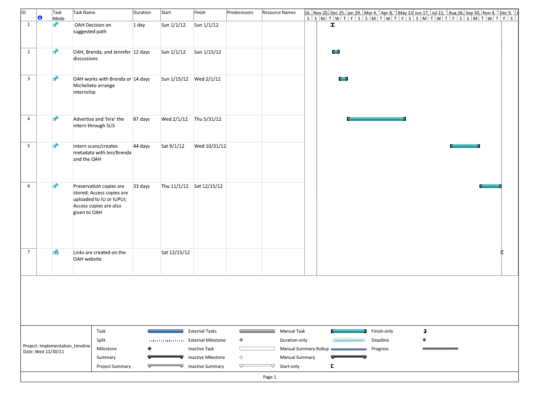

**Appendix**

**Figure 6. Artifact model of the OAH Organizational Chart**

**Figure 7. Interview Quietionnaire**

**First Round of Interviews Questionnaire (Tech Questions)**

Interview subject__________________________________________

Interviewees______________________________________________

Date______________________

Start time__________________ End time________________________

1) What's Your Job Title?

2) How long have you worked at the OAH?

3) What are your responsibilities?

4) To whom do you report?

5) What factors make your work successful (ie, what about your job makes you feel like you got something done well)?

6) What's your relationship to OAH publications?

7) Did you have any role in the publication of the OAH Newsletter?

8) How often do you consult the OAH Newsletter archives?

9) What are your thoughts about the OAH Newsletter only being available in hard copy form in a few known locations?

10) How much interest do you have in the OAH Newsletter archives?

11) How much interest do you think the membership has in the OAH Newsletter Archives?

12) Have you ever had to retrieve electronic versions of the OAH Newsletter for members?

13) How often do you use the OAH website?

14) How has the speed of your internet connection affected your workflow?

15) What resources on the OAH website do you use the most?

(15a How often do you update the OAH website?

(15b How much time do you spend managing the website?

(15b How often do you use the website to access publications?)

16) How much do you think access to the OAH Newsletter archives would enhance the membership experience?

17) How does the culture of the OAH affect what work you accomplish (in other words – how does the set up of the organization either help or hinder what you get done)?

18) How does having multiple offices affect work your work?

19) Is there a procedure in place to scan paper archive items?

20) Does the OAH have the necessary equipment/software to scan the Newsletter?

21) Who would likely do the scanning to archive the OAH newsletter?

22) Can we contact you with follow-up questions?

**Interview Notes/Thoughts**

|  |  |
| --- | --- |
| Figure 8. Survey questions and results.  1. How often do you visit the OAH website (<http://www.oah.org>)? | |
|  | |  |  |  |  | | --- | --- | --- | --- | | Once a week |  | 6 | 17% | | Once a month |  | 7 | 20% | | Once every couple of months |  | 9 | 26% | | Once or twice per year |  | 12 | 34% | | Never |  | 0 | 0% | |  |  |  |  | |

|  |  |
| --- | --- |
| 2. How often do you use the online editions of OAH publications provided to you by your membership? | |
|  | |  |  |  |  | | --- | --- | --- | --- | | Once a week |  | 6 | 17% | | Once a month |  | 7 | 20% | | Once every couple of months |  | 11 | 31% | | Once or twice per year |  | 8 | 23% | | Never |  | 2 | 6% | |  |  |  |  | |

|  |  |
| --- | --- |
| 3. How often do you consult past editions of the quarterly newsletters of the OAH? | |
|  | |  |  |  |  | | --- | --- | --- | --- | | Once a week |  | 0 | 0% | | Once a month |  | 6 | 17% | | Once every couple of months |  | 7 | 20% | | Once or twice per year |  | 12 | 34% | | Never |  | 9 | 26% | |  |  |  |  | |

|  |  |
| --- | --- |
| 4. The back issues of the quarterly OAH NEWSLETTER have significant historical value. | |
|  | |  |  |  |  | | --- | --- | --- | --- | | Strongly Agree |  | 10 | 29% | | Agree |  | 18 | 51% | | Neither Agree or Disagree |  | 6 | 17% | | Disagree |  | 0 | 0% | |  |  |  |  | | Strongly Disagree |  | 0 | 0% | |

|  |  |
| --- | --- |
| 5. It would benefit the American history research community if back issues of the quarterly OAH NEWSLETTER were available online. | |
|  | |  |  |  |  | | --- | --- | --- | --- | | Strongly Agree |  | 16 | 46% | | Agree |  | 15 | 43% | | Neither Agree or Disagree |  | 2 | 6% | | Disagree |  | 1 | 3% | | Strongly Disagree |  | 0 | 0% | |  |  |  |  | |

|  |  |
| --- | --- |
| 6. It would benefit members of the OAH if back issues of the quarterly OAH NEWSLETTER were available online. | |
|  | |  |  |  |  | | --- | --- | --- | --- | | Strongly Agree |  | 15 | 43% | | Agree |  | 15 | 43% | | Neither Agree or Disagree |  | 4 | 11% | | Disagree |  | 0 | 0% | | Strongly Disagree |  | 0 | 0% | |  |  |  |  | |

|  |  |
| --- | --- |
| 7. Would you be interested in having the back issues of the quarterly OAH NEWSLETTER as an online resource? | |
| https://chart.googleapis.com/chart?cht=p&chs=345x150&chco=0000e0&chl=Yes%20%5B31%5D%7CNo%20%5B3%5D&chd=e%3A6VFp | |  |  |  |  | | --- | --- | --- | --- | | Yes |  | 31 | 89% | | No |  | 3 | 9% | |

## Optional Questions

The following demographic questions are optional.

|  |  |
| --- | --- |
| 8. With which of these constituencies do you primarily identify? | |
|  | |  |  |  |  | | --- | --- | --- | --- | | Four-year college/university faculty |  | 13 | 37% | | Community college faculty |  | 1 | 3% | | Independent scholars |  | 5 | 14% | | Precollegiate faculty |  | 4 | 11% | | Public historians |  | 6 | 17% | | Graduate students |  | 5 | 14% | |  |  |  |  | |

|  |  |
| --- | --- |
| 9. What is your age? | |
|  | |  |  |  |  | | --- | --- | --- | --- | | 35 or under |  | 5 | 14% | | 36 - 45 |  | 5 | 14% | | 46 - 55 |  | 11 | 31% | | 56 - 65 |  | 9 | 26% | | 65 or older |  | 4 | 11% | |

10. Please feel free to share any additional comments with us. Thank you for your responses!

Any resource that can be made available on lie tote education community is an excellent idea!Please work to get back issues of American history journals available online, as more independent scholars don't have ready access to institutional subscriptions of JSTOR or EBESCO. Thanks.I have recently been frustrated in accessing past issues of the Newsletter in preparation of a book on the state of the discipline of history today. To get correct citations (to satisfy both myself and my editor), I had to phone Mike Regoli, who was characteristically thorough, good natured, and informed in helpi...

Number of responses without dates: 1

|  |  |
| --- | --- |
| Number of daily responses | |
| https://chart.googleapis.com/chart?cht=lc&chs=300x150&chco=dcca02&chl=11%2F6%2F2011%7C11%2F18%2F2011&chly=15%7C12%7C9%7C6%7C3%7C0&chd=e%3AAA..AAIiu7IiAAAAAAAAAAMzER | |  | | --- | |  | |

Figure 9. Cost and Benefit Analysis Spreadsheet